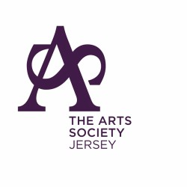
PATRON LADY DALTON
MEMBERSHIP APPLICATION FORM

TITLE: MR/MRS/MISS/MS/OTHER

FULL NAME (S)

ADDRESS INCLUDING POST CODE

CONTACT TELEPHONE NUMBER

EMAIL ADDRESS

PLEASE INDICATE HOW YOU WILL PAY

If we email information to you: If we post information to you:

£55 per person £65 per person

£100 per couple £115 per couple
Either

□ Make an online payment to Nat West St Helier,

Sort Code: 60-12-03 Account No: 27355039

Quoting your full name as the reference

OR

□ Enclose a cheque payable to The Arts Society Jersey with this form

KINDLY FORWARD THE COMPLETED FORM TO
Mary Adelmann, 37 Chevalier Road, St Helier, JE2 4LP
mary@theartssocietyjersey.org
01534874420

GDPR COMPLIANCE:
- Members’ details will be processed fairly and lawfully in order to satisfy the agreement entered with you on your admittance to membership. This will ensure that you receive the latest news and information about all upcoming events.
- Members’ details will be passed to “The Arts Society” to enable inclusion on the mailing of the quarterly magazine and other communications including information about any upcoming national events or items of legitimate interest
- Members’ details may be passed to “The Arts Society Area”, or other affiliated societies for the purposes of disseminating relevant information of legitimate interest
- Your details will be kept safely and securely and you have the ability to opt out of our communications at any time

