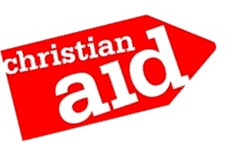
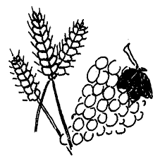
Devizes Churches Together

Harvest Supper

St Andrew’s Church
Long Street

Saturday 8th October

@7pm

Entrance with ticket ONLY: Adults £5
Children are free but need a ticket too!

